
Comsats University Islamabad, Lahore Campus

Assignment <3> – SPRING 2025
Course Title | Information Security | Course Code |  | CSC432 | Credit Hours |  |  | 3(2,1)
Instructor/s | Dr. Muhammad Sharjeel | Program Name |  | BSSE
Semester | 8th | Batch | FA21 | Section | A | Date | June 03, 2025
Time Allowed | 1 week | Maximum Marks
Student Name: | Aoun-Haider | Reg No. |  | FA21-BSE-133
Question Statement [CLO-3]; Bloom Taxonomy Level: <Applying>
Complete challenges on hackthissite.org
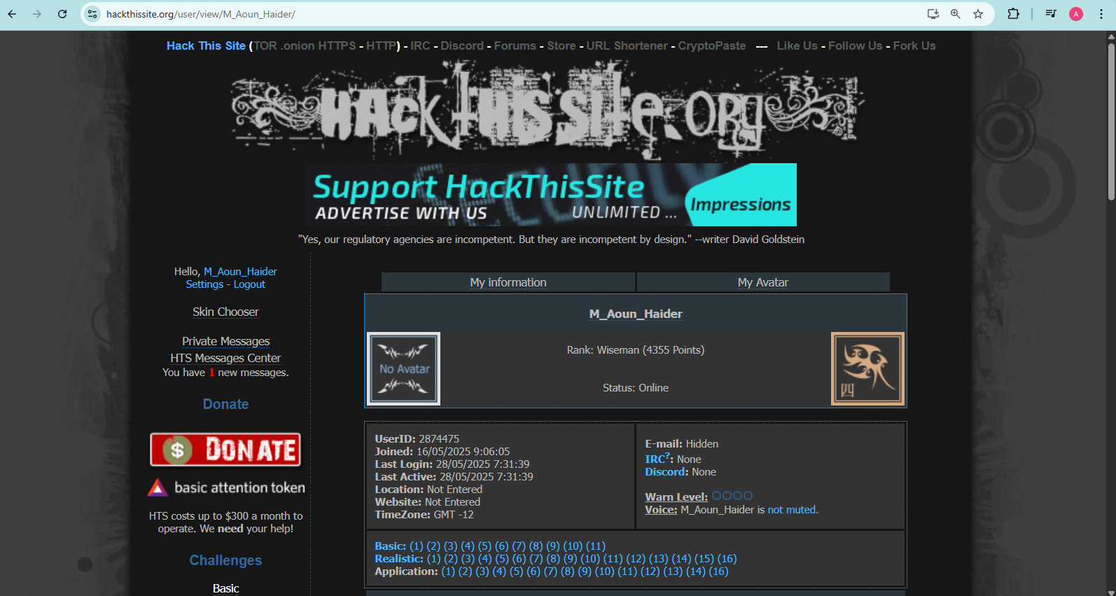
I have completed 80 challenges, all basic, realistic and some of the application phase and my account username is M_Aoun_Haider. Below is the screenshot of my account profile where list of all completed challenges are visible:

